# 

|  |  |
| --- | --- |
| Date | 8/2/17 |
| Product | Cloud Integration - Azure |
| Requestor | Ben Swoboda |

# 

# Overview

The current Azure automation only accounts for A) creating new accounts and B) merely sending a slack message to #bluesquad when the customer wants to migrate an existing account. We want to automate the manual steps that follow the slack notification for B.

The goal is to automate the end-to-end process of migrating a customer’s active Azure tenant and Subscription into our CSP purview. From Cloud Application Manager’s New Provider option, the authorized user should be able to select “Migrate my account to CenturyLink for consolidated billing and Platform Support” and input a few details so the Cloud Integration can send a partnership request to the correct customer and recognize when they have moved into our territory CSP.

Details:

* Only users with authorized country codes will successfully be able to submit requests for migration (Currently, that is US and GB)
* When the user selects “Migrate my account to CenturyLink for consolidated billing and Platform Support” present the following items in the UI:
  + Target Email Address field (and a radio button allowing user to populate their own email into the field)
    - User may choose to enter their own CAM-registered email or manually enter one. (See UI, below)
  + Azure primary domain field
  + A link to a Knowledge Base article.
  + Checkbox for Term and Conditions (for the appropriate territory)
* When the user fills in the required information and submits
  + Users from un-authorized country codes will be given an error
  + A link request (from the correct territory, UK or US) will be sent to the email they entered
  + The CAM provider moves into “Under Review” status
  + Notify #cam-cloud-integ in cl-cloud.slack.com and #cam-onboarding in ctl-connected.slack.com with a message. (See Appendix A)

(After the customer accepts the invitation, their Customer account will move into the appropriate territory partner center.)

* Watch for and recognize when the customer accepts the link and moves into the correct territory’s list of customers. (Watch for the domain they provided.)
* Once the customer has moved into the correct territory’s list:
  + If they did not bring any Azure subscriptions, notify #cam-cloud-integ in cl-cloud.slack.com and #cam-onboarding in ctl-connected.slack.com with a message. (See Appendix A)
* Watch for new Subscriptions
  + If this is the first subscription associated with a Customer, create a native application for the subscription on the customer’s behalf, giving it the appropriate role.
  + Update the Cloud Integration Provider Relationship API with the Azure Subscription IDs the Customer brought with them and associate with CLC Alias.
* Once the first subscription for a given Azure domain appears:
  + Update the existing “Under Review” CAM provider associated with the domain they submitted:
    - Subscription ID: The active subscription ID
    - Client ID: The Application ID (See technical considerations, Native App section)
    - Secret: The key value generated (See technical considerations, Native App section)
    - Tenant: Name of Customer URL (everything after @)
  + Attempt to synchronize

# 

# UX Design and Sample Scenarios

This is the New Provider selected:



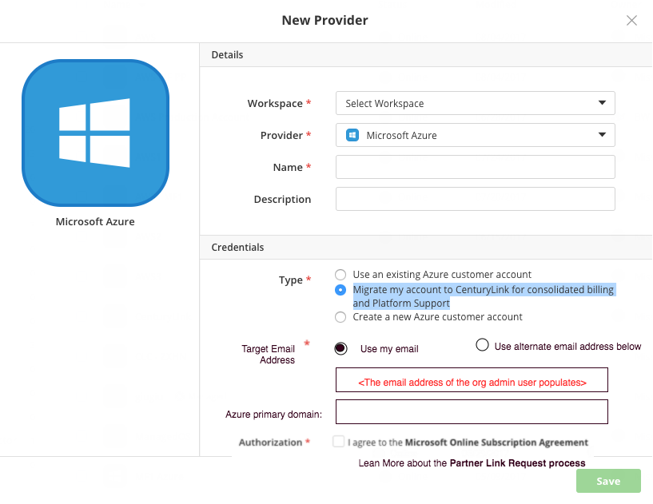

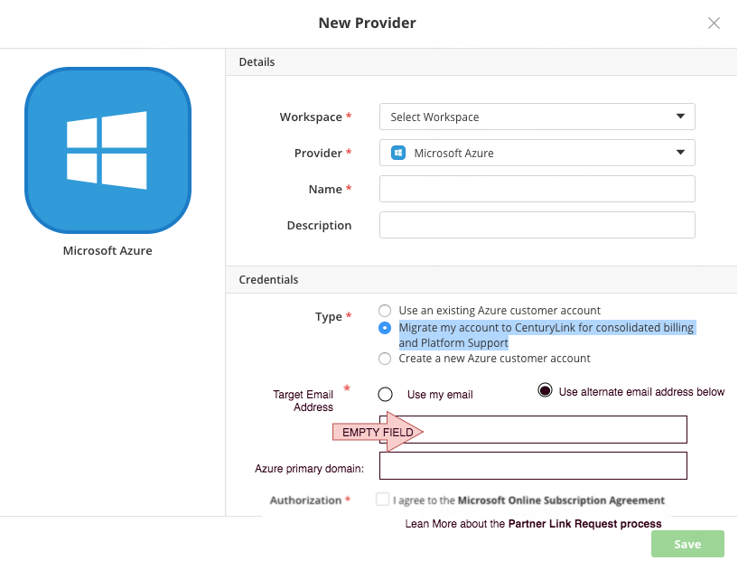

Technical Considerations

For an understanding of how the Native application works:

<https://github.com/amwatson1s/kb/blob/master/kb_for_elasticbox/KB%20for%20Azure%20CSP%20and%20Elasticbox.md>

These are just suggestions about how Engineering might be able to accomplish some of the goals.

* For getting the Partner Request URL

<https://apidocs.microsoft.com/services/partnercenter#!/RelationshipRequest/Get_v_version_customers_relationshiprequests_indirectCloudSolutionProviderId_indirectCloudSolutionProviderId_value_indirectResellerId_indirectResellerId_value>

* For watching whether a customer is added to our customer list

<https://apidocs.microsoft.com/services/partnercenter#!/Customer/Get_v_version_customers_filter_filter_value_size_size_value_seekOperation_seekOperation_value>

Appendix A – Slack Notifications

Currently, production updates from Providers to #blusquad in cl-cloud.slack.com. Those all need to be changed to #cam-cloud-integ in cl-cloud.slack.com and #cam-onboarding in ctl-connected.slack.com.

When the customer has submitted their request through CAM, send the following notification to #cam-cloud-integ in cl-cloud.slack.com and #cam-onboarding in ctl-connected.slack.com. The highlighted pieces are different than the existing notification that goes to bluequad.

@Channel: Provider account creation in CAM:

CAM User Email: <user email >

Invite recipient: < Target Email Address >

Azure domain: <domain>

Acceptance date and time: <date and time>

Username: <username>

Full name: <firstName lastName>

Account Type: <green or brown-field>

Organization: <org>

Cloud service: Microsoft Azure

When the customer has moved into Customer List, but they have not brought any Subscriptions with them.

* @here: <companyName> with domain <domain> has moved into the <Territory domain> CSP but did not bring any Azure Subscriptions. Please contact the CAM org admin to confirm whether they are ready to coordinate the rest of the migration. If you are not certain which this company this is, please reference any customers who have accepted Terms and Conditions for an Azure provider within the last fifteen days.
  + <companyName> comes from Microsoft API
  + <Territory domain> is determined by whichever partner center was being watched.

Appendix B – Manual User Experience

The following was created for the Onboarding Team so they could understand the manual process of sending a partnership relationship request (link request) to a customer.

Azure Partner Relationship with CenturyLink

# Account Review

Please review this Microsoft article <https://docs.microsoft.com/en-us/azure/azure-resource-manager/resource-group-move-resources> to ensure you have a strategy for determining which resource can move to CenturyLink’s care. If you are moving from an Enterprise Agreement to Centurylink, that definitely requires a subscription move and certain resources will not transfer.

# Leave Previous Partner Relationship

The Office 365 Admin has this ability

(This may not always apply)



# Accept New Partner Relationship Request

Use the link that is sent to you.

|  |
| --- |
| Ben Swoboda of CenturyLink would like to be your Microsoft Cloud Solution Provider for your Microsoft Cloud account.  Click the following link to accept this invitation and authorize CenturyLink to be your Microsoft Cloud Solution Provider.  https://portal.office.com/partner/partnersignup.aspx?type=ResellerRelationship&id=bed6f062-6160-4d51-a573-9dc37af1cd70&csp=1&msppid=0  Additional partner information:  CloudSupport@CenturyLink.com  844-874-5167 |

Sign Into Office 365



Authorize the move



# Transfer Resources to New Subscription

In some cases, CenturyLink will create a new Azure Subscription and a user for the purposes of transferring resources from your old Azure Subscription to the new one under our care. This is a metadata move that does not cause any outages or downtime.

CenturyLink will need to tell you what user to expect.

Add the CenturyLink User to your old subscription and give that user the Owner or Contributor role.

